**Model Development Phase Template**

|  |  |
| --- | --- |
| Date | 10 July 2024 |
| Team ID | 739923 |
| Project Title | Predicting the Compressive Strength of Concrete |
| Maximum Marks | 4 Marks |

**Initial Model Training Code, Model Validation and Evaluation Report**

The initial model training code will be showcased in the future through a screenshot. The model validation and evaluation report will include classification reports, accuracy, and confusion matrices for multiple models, presented through respective screenshots.

**Initial Model Training Code:**

Paste the screenshot of the model training code

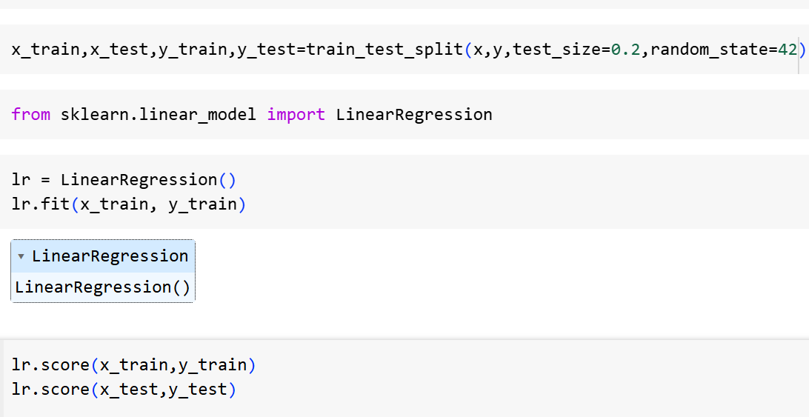

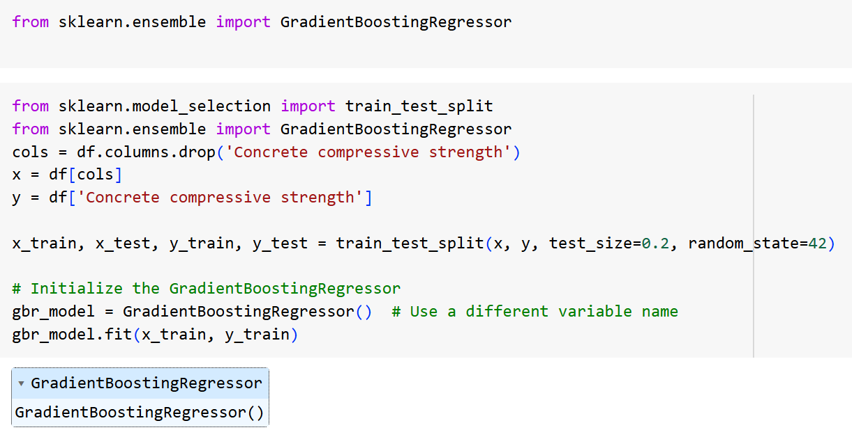

**Model Validation and Evaluation Report:**

|  |  |  |  |
| --- | --- | --- | --- |
| **Model** | **Training Report** | **Accuracy** | **Metrix** |
| Linear Regression |  | 0.74 |  |
| Gradient Boosting Regressor |  | 0.88 |  |